**Creating and starting a VM instance**

An instance is a virtual machine (VM) hosted on Google's infrastructure. An instance group is a collection of virtual machines running a single application.

1. Once you first log in, your screen should look similar to this.

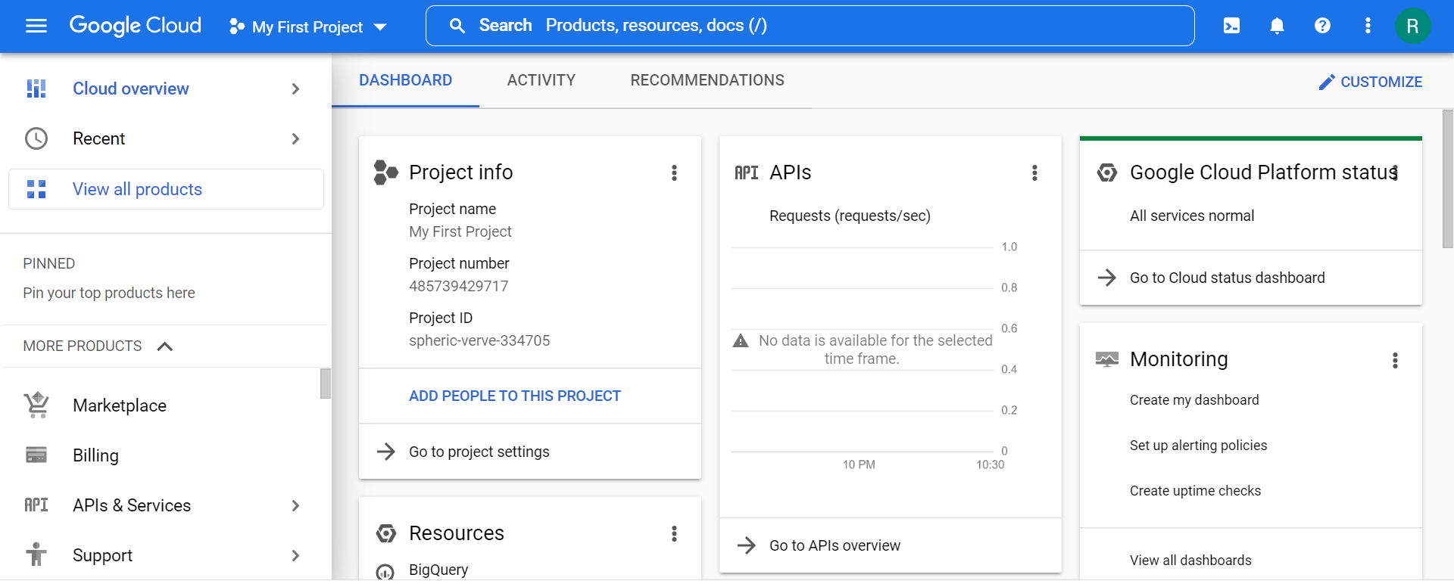

1. Click on the project selector drop-down menu at the top of the screen.

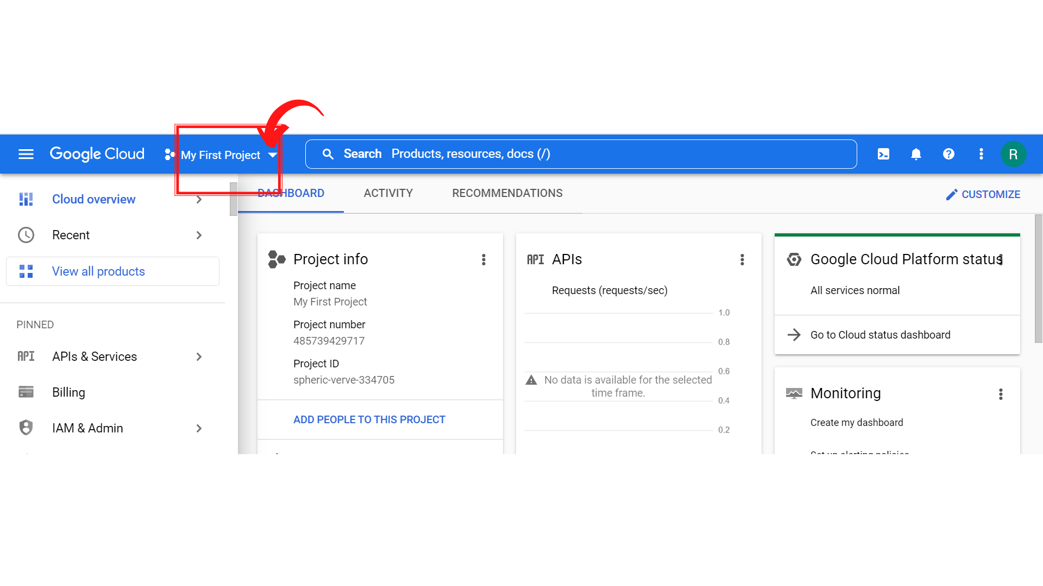

1. Since, we are doing labs on a Security Labs project, Click on *“Security Labs”*.

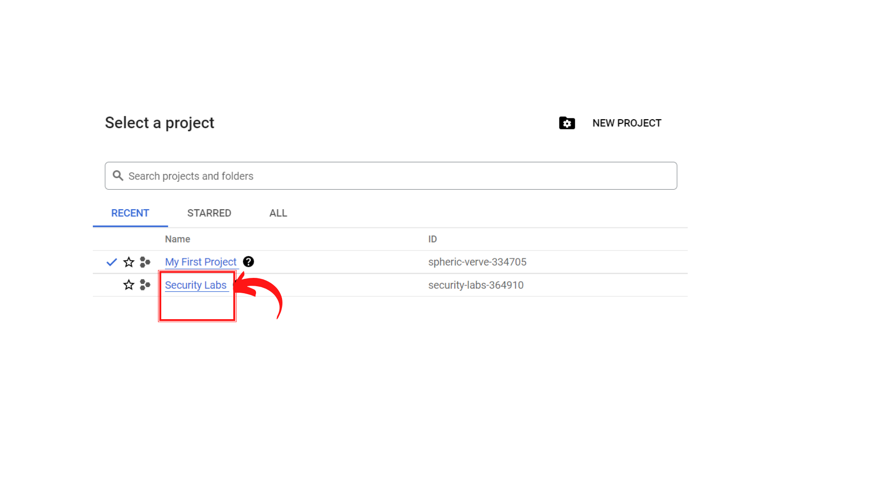

1. Your screen should look similar to this with project info changed to “*Security Labs”* project.

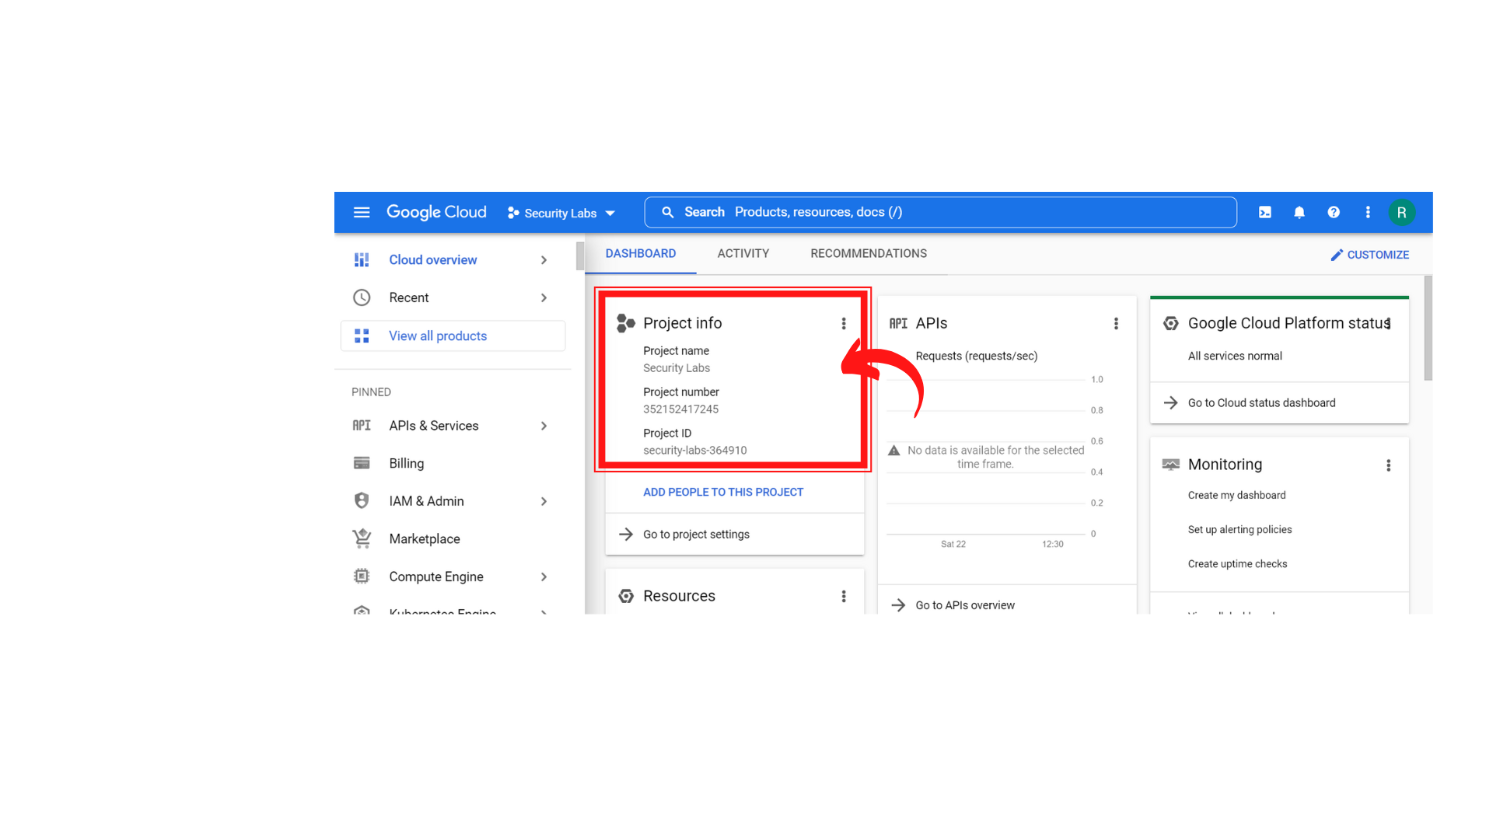

1. To create a new VM instance, click on *“Compute Engine → VM instances.”*

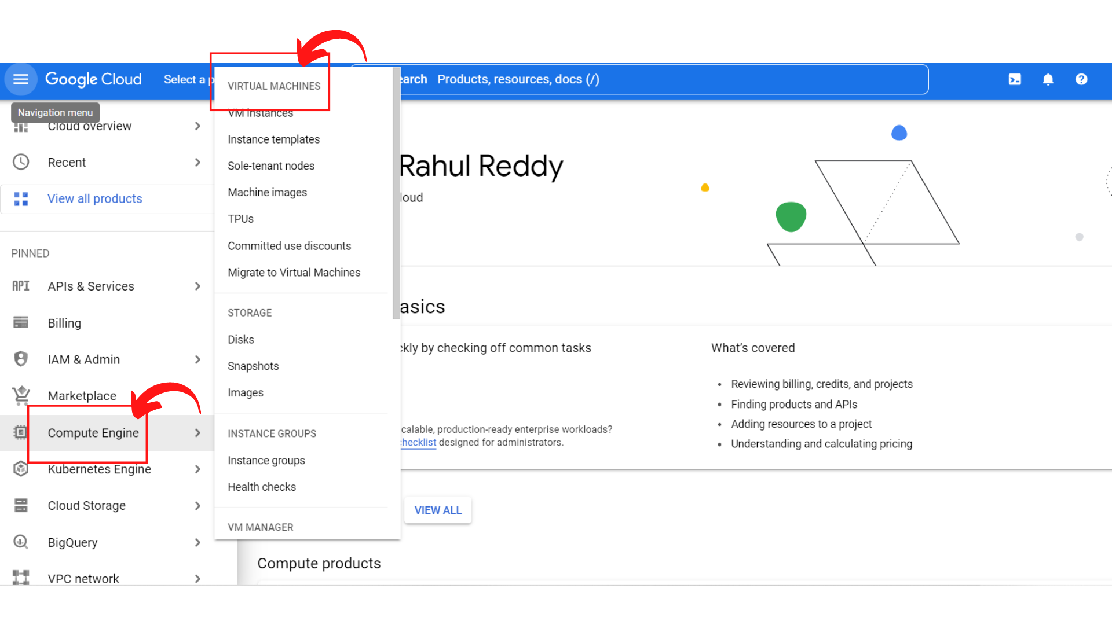

1. Your screen should look similar to this if your *“Compute Engine API”* is not enabled.

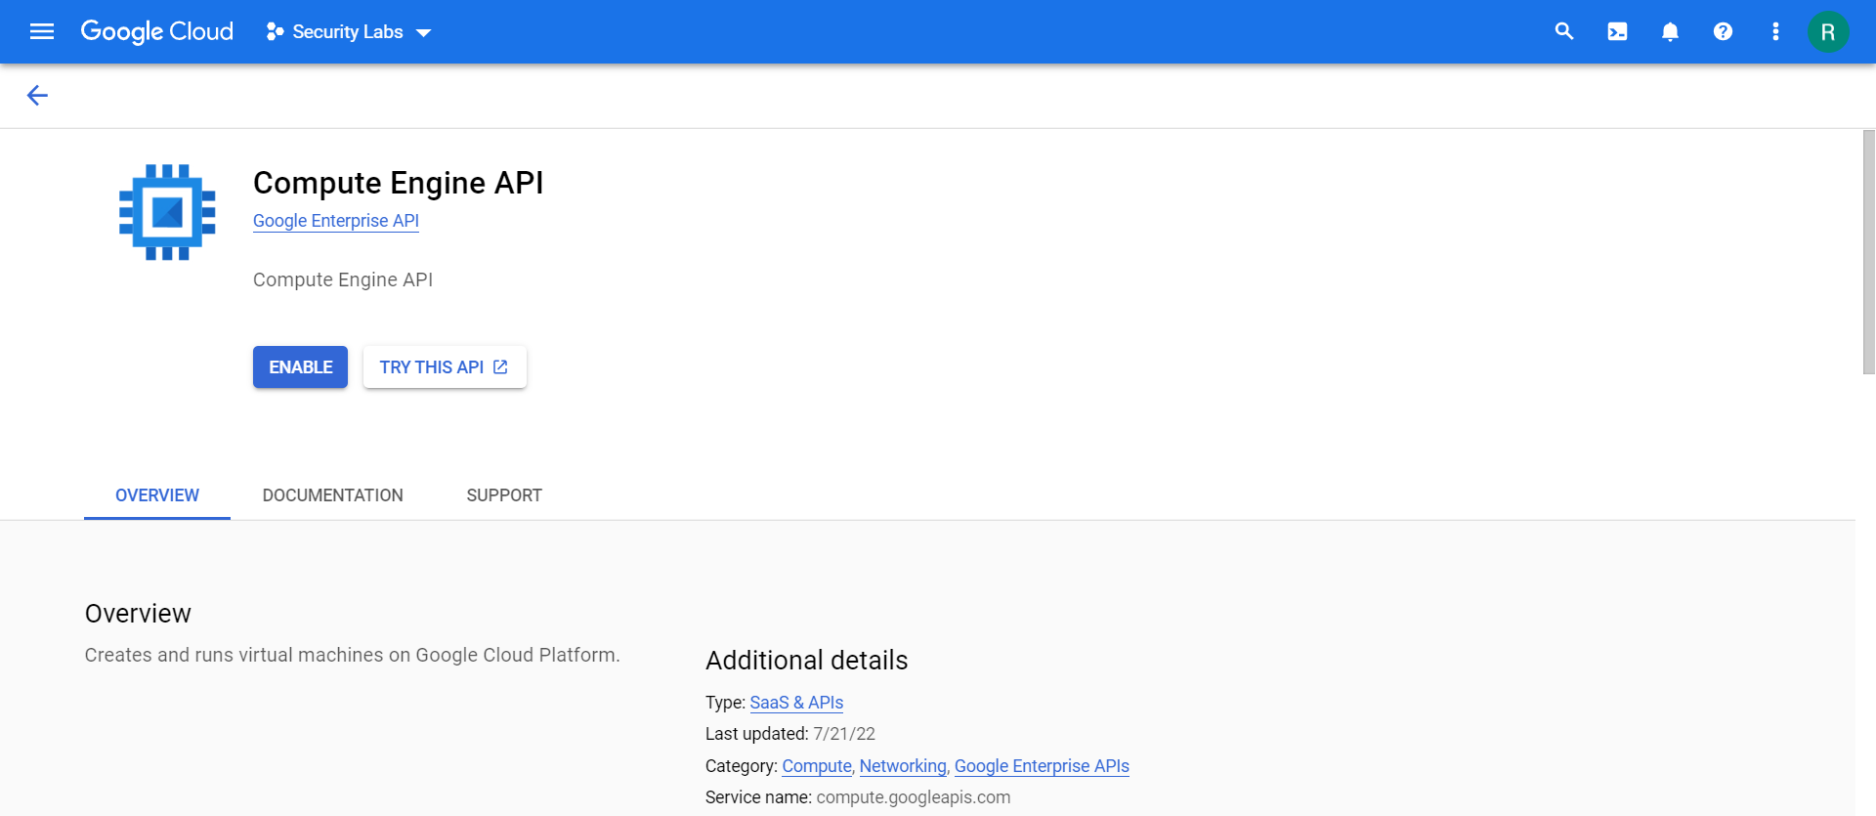

1. Click on *“Enable”*

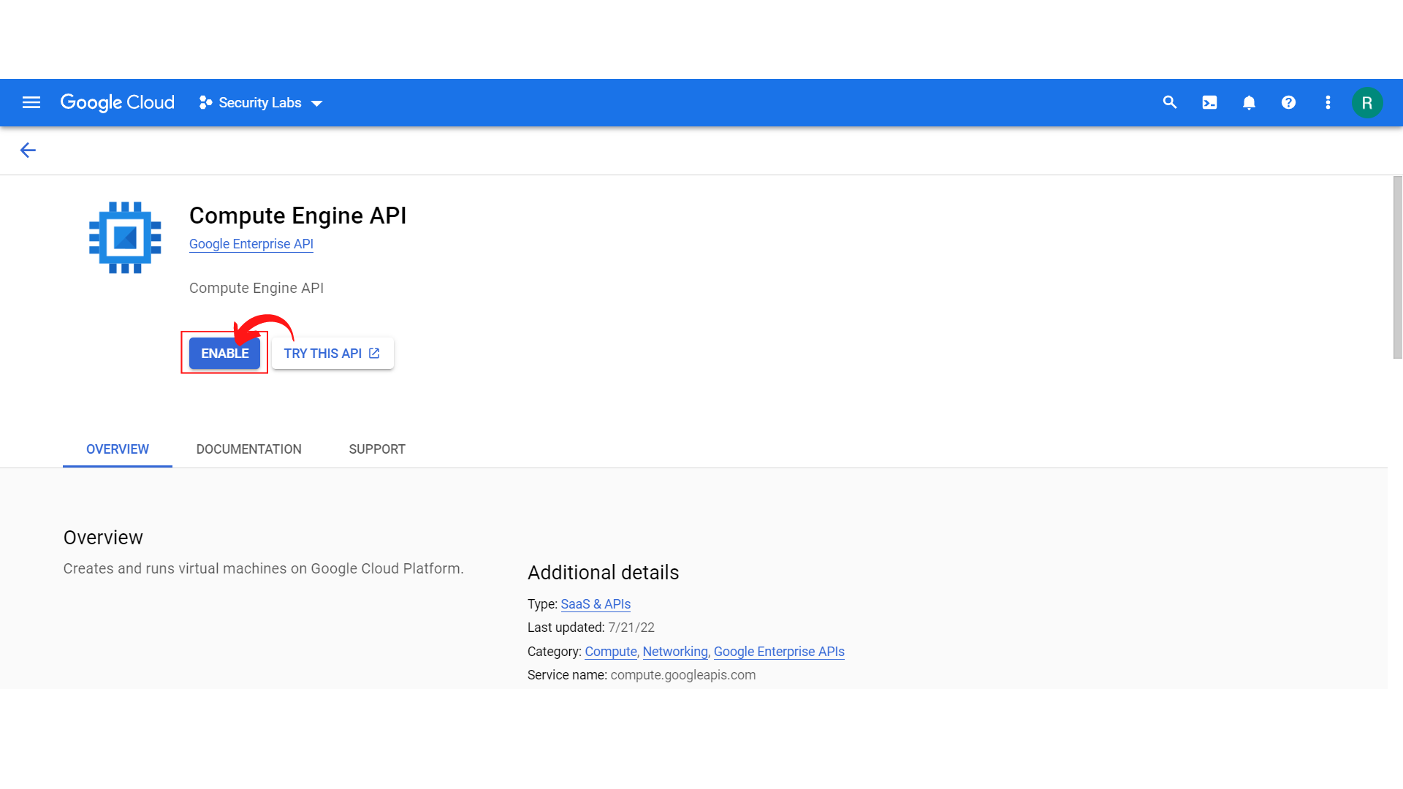

1. Once the Compute Engine API is enabled, your screen should look similar to this.

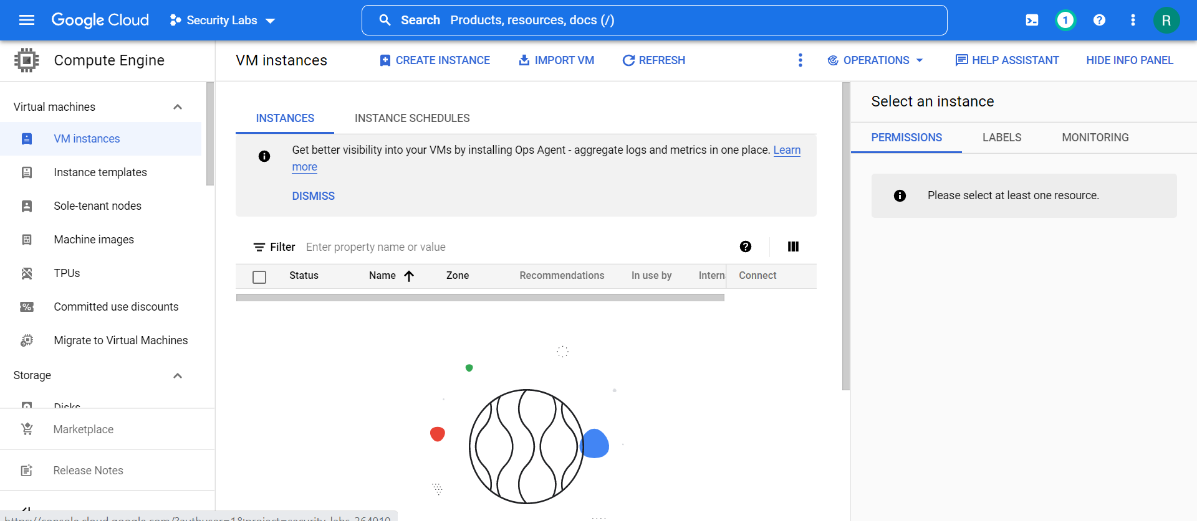

1. Click → “*Create Instance”*

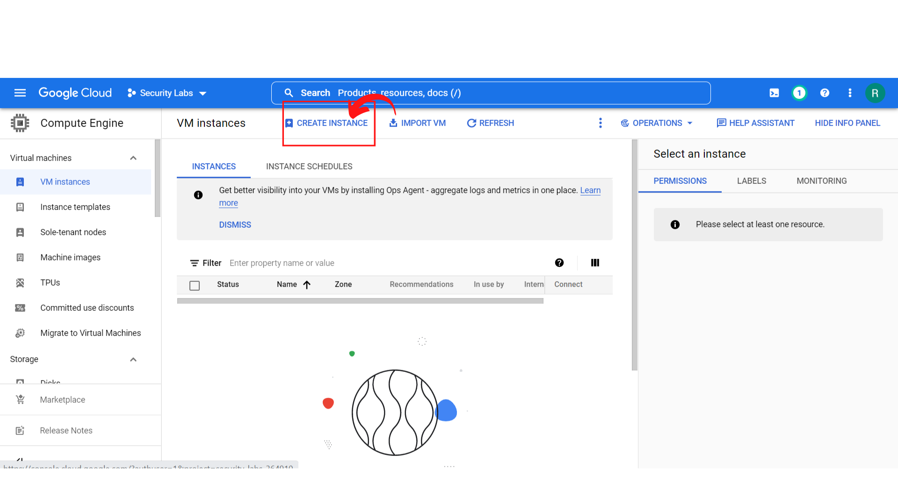

1. Your screen should look similar to this.

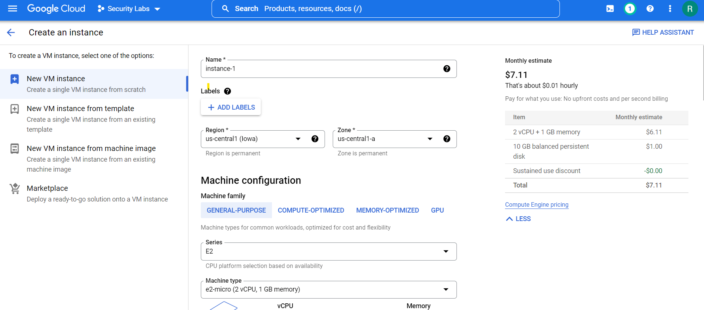

1. Enter the *Instance name, Add Labels* and *choose your Region and Zone correctly.*

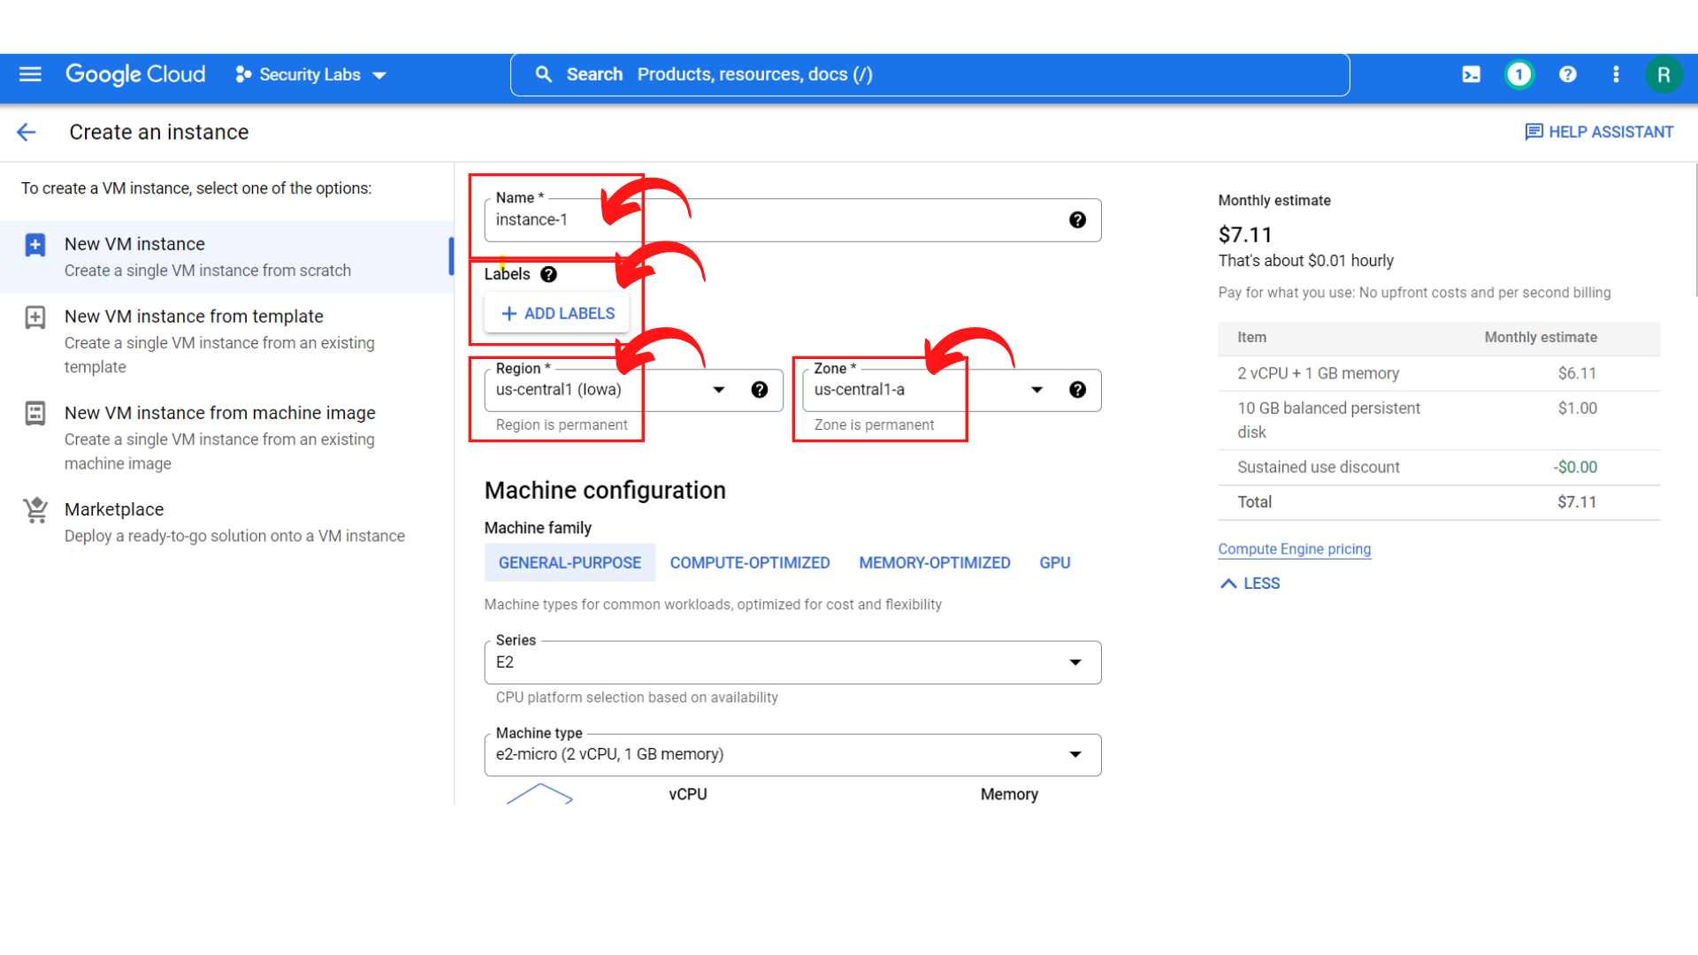

1. Now scroll down, you will see the “*Machine configuration”* section, select Machine Family → General purpose.You can select as per your requirements, but here default is General purpose.
2. The Default *Series → E2 and Machine Type → e2-small (2 vCPU, 2 GB memory). You can always select based on your requirements for the project.*

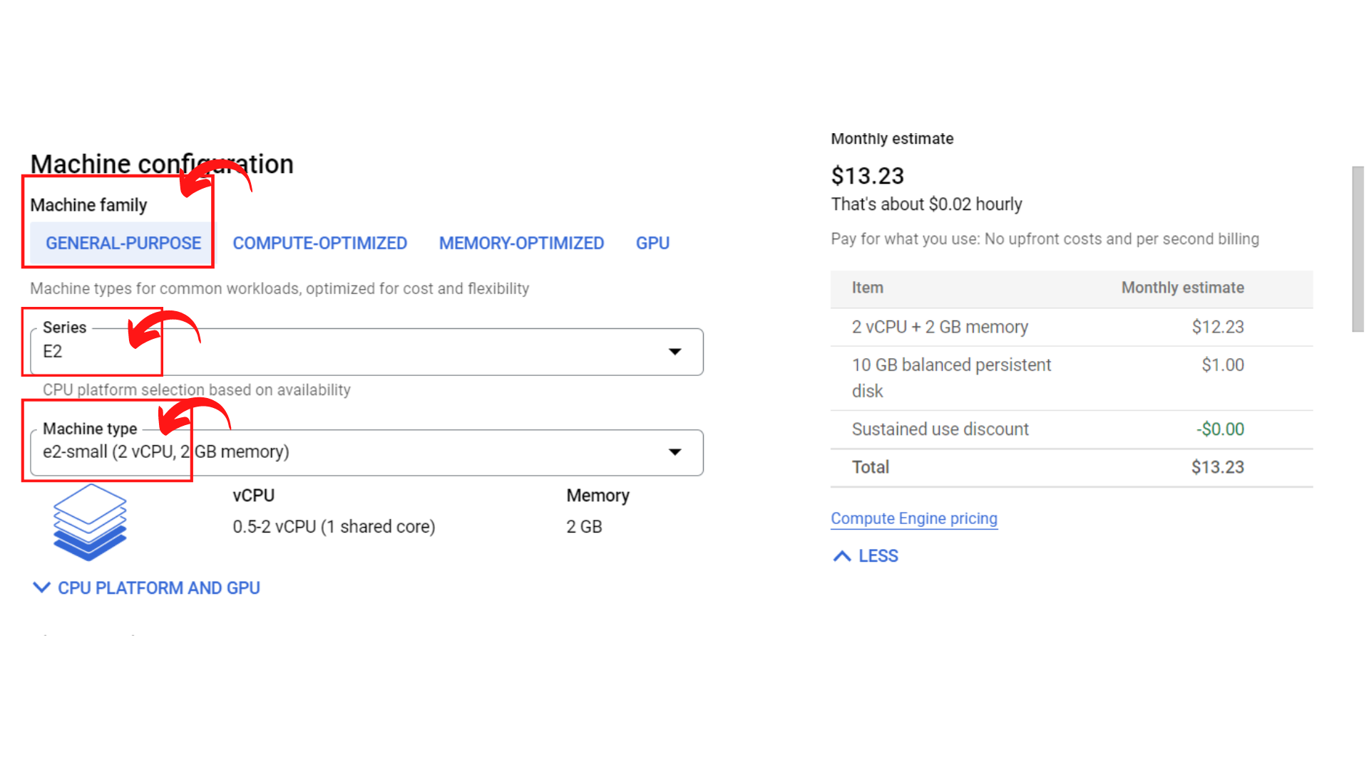

1. Now scroll down, You will see “*Display Device”* where you can Enable to use screen capturing and recording tools.
2. Under the *“Confidential VM service”* section, you can Enable Confidential VM service. By default it is disabled.
3. Under the *“Container”* section, you deploy the container image to this VM instance.

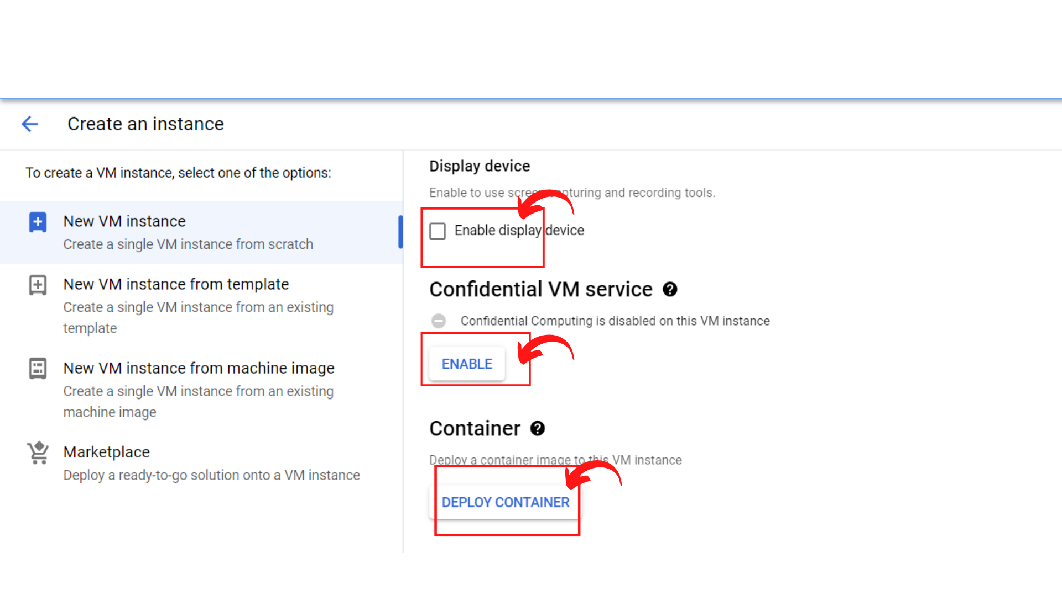

1. Now Scroll down, you will see the *“Boot disk” section.* In this section you will see the Name,Type, Size, License type and Image of the Boot disk. You can change “Boot disk” by clicking on the *“Change”* button.

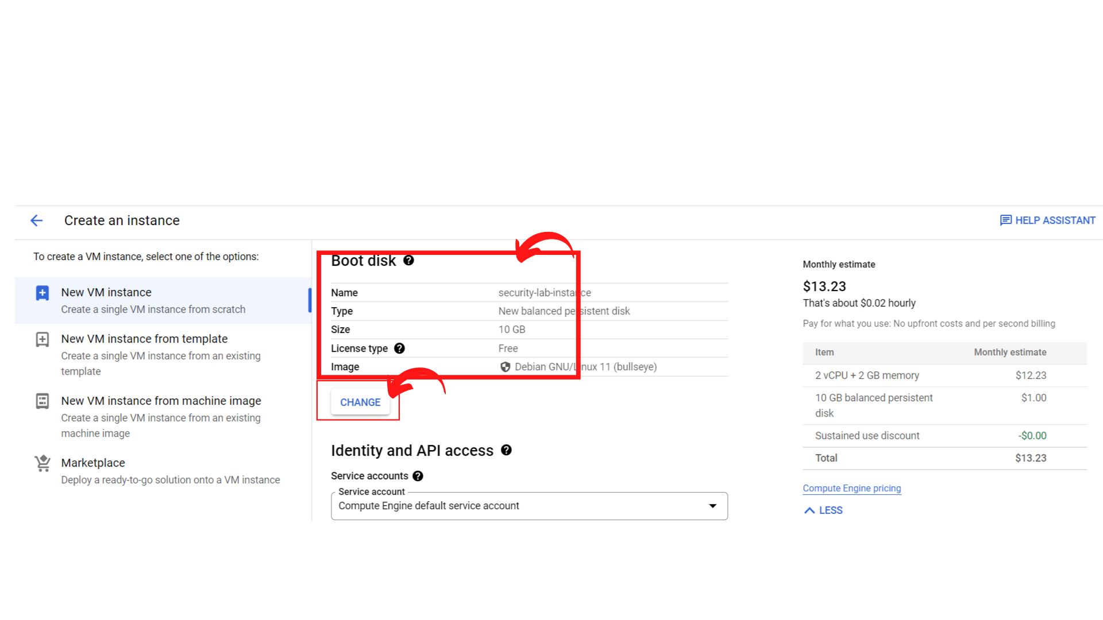

1. If you click on the “*Change”* button on “Boot Disk”, you will see a screen similar to this where you can select *Operating system, version, boot disk type, size and click on “select”*

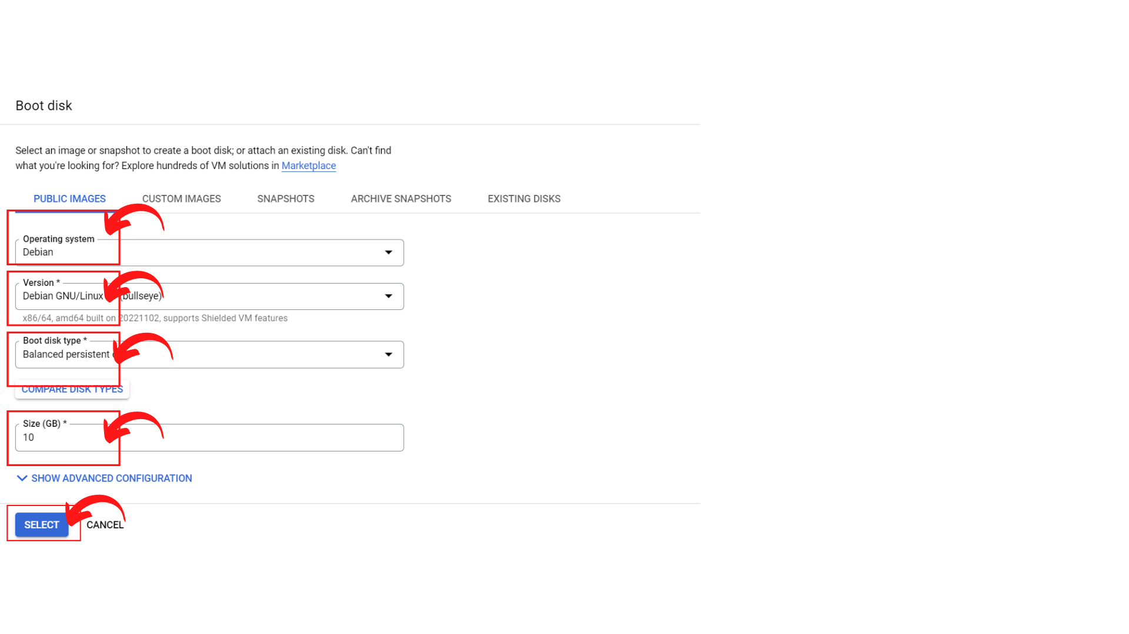

1. Now scroll down, you will see the *“Identity and API access” section*  where you can select your *service account*. Here I'm leaving it as the default Service account.
2. Under the “Access Scopes” section, where you can Select the type and level of API access to grant the VM.
3. Under the *“Firewall”* section, where you can Add tags and firewall rules to allow specific network traffic from the Internet.

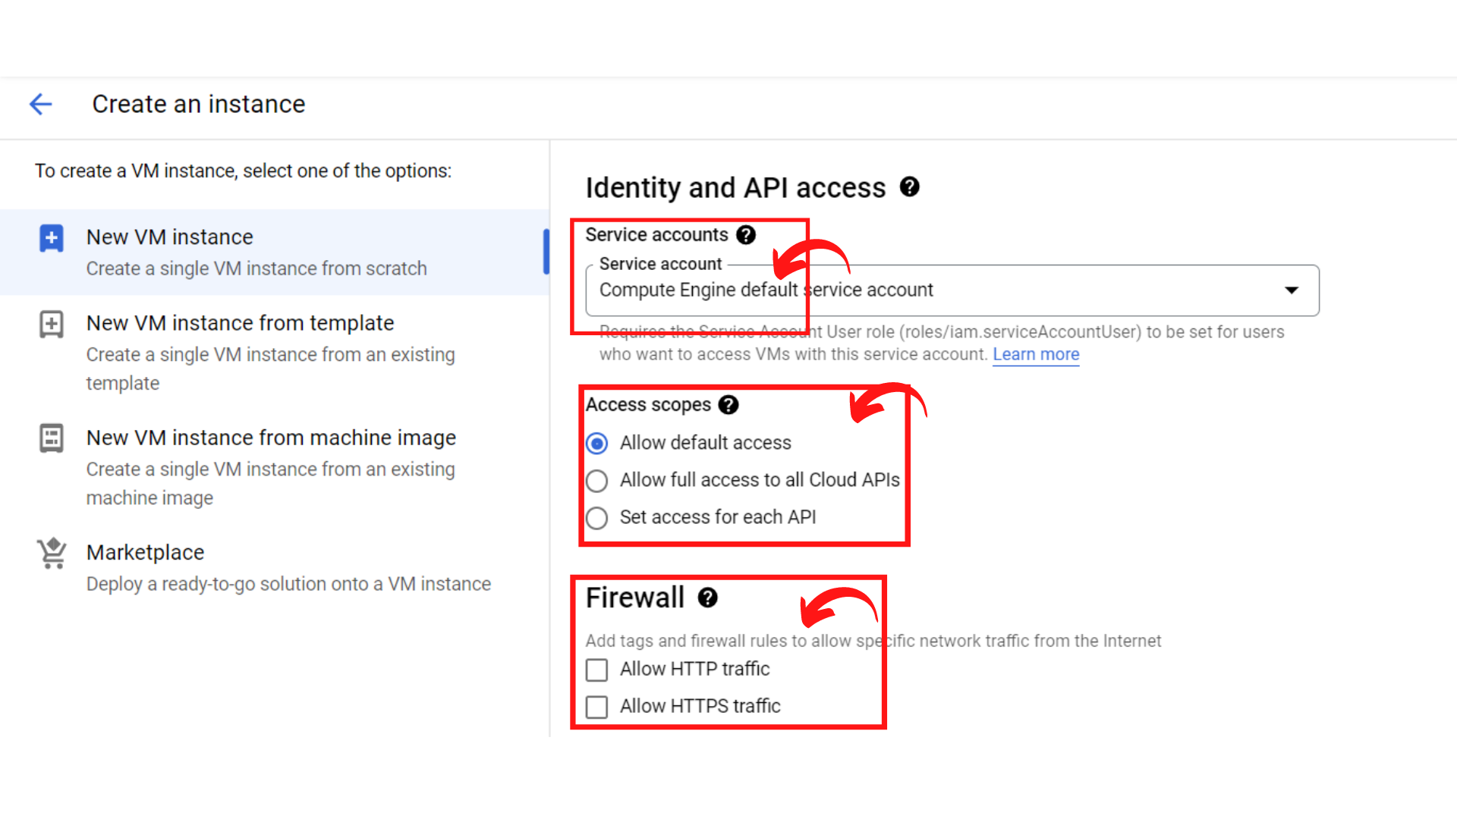

* Now scroll down, you will see the “Advanced options” where you can select the
  + *“Networking” → to add “Hostname and network interfaces”,*
  + *“Disks” → to add “Additional disks”,*
  + *“Security” → to add “SSH keys”,*
  + *“Management” → to add “Description, deletion protection, reservations, automation, and availability policies”,*
  + *“Sole-tenancy” → to add “Node affinity labels and CPU overcommit.”*

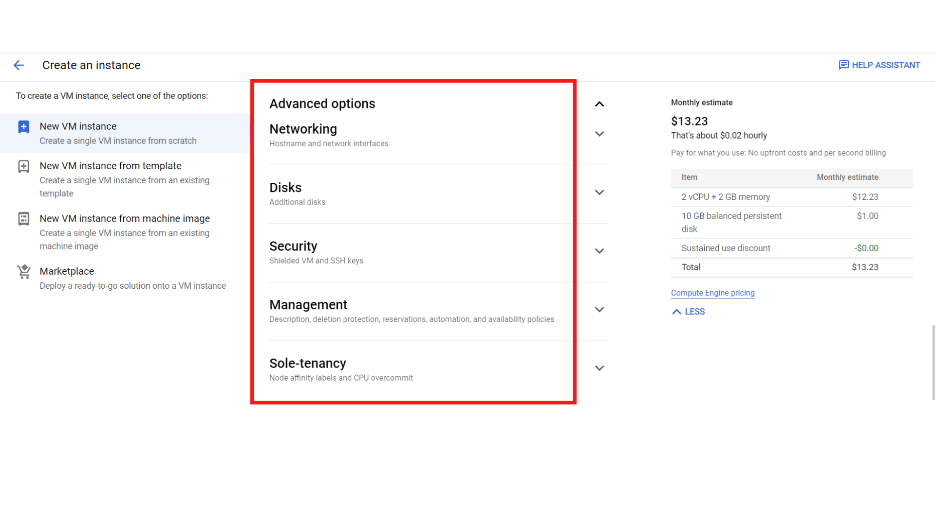

1. Now scroll down, and click on the *“Create”* button.

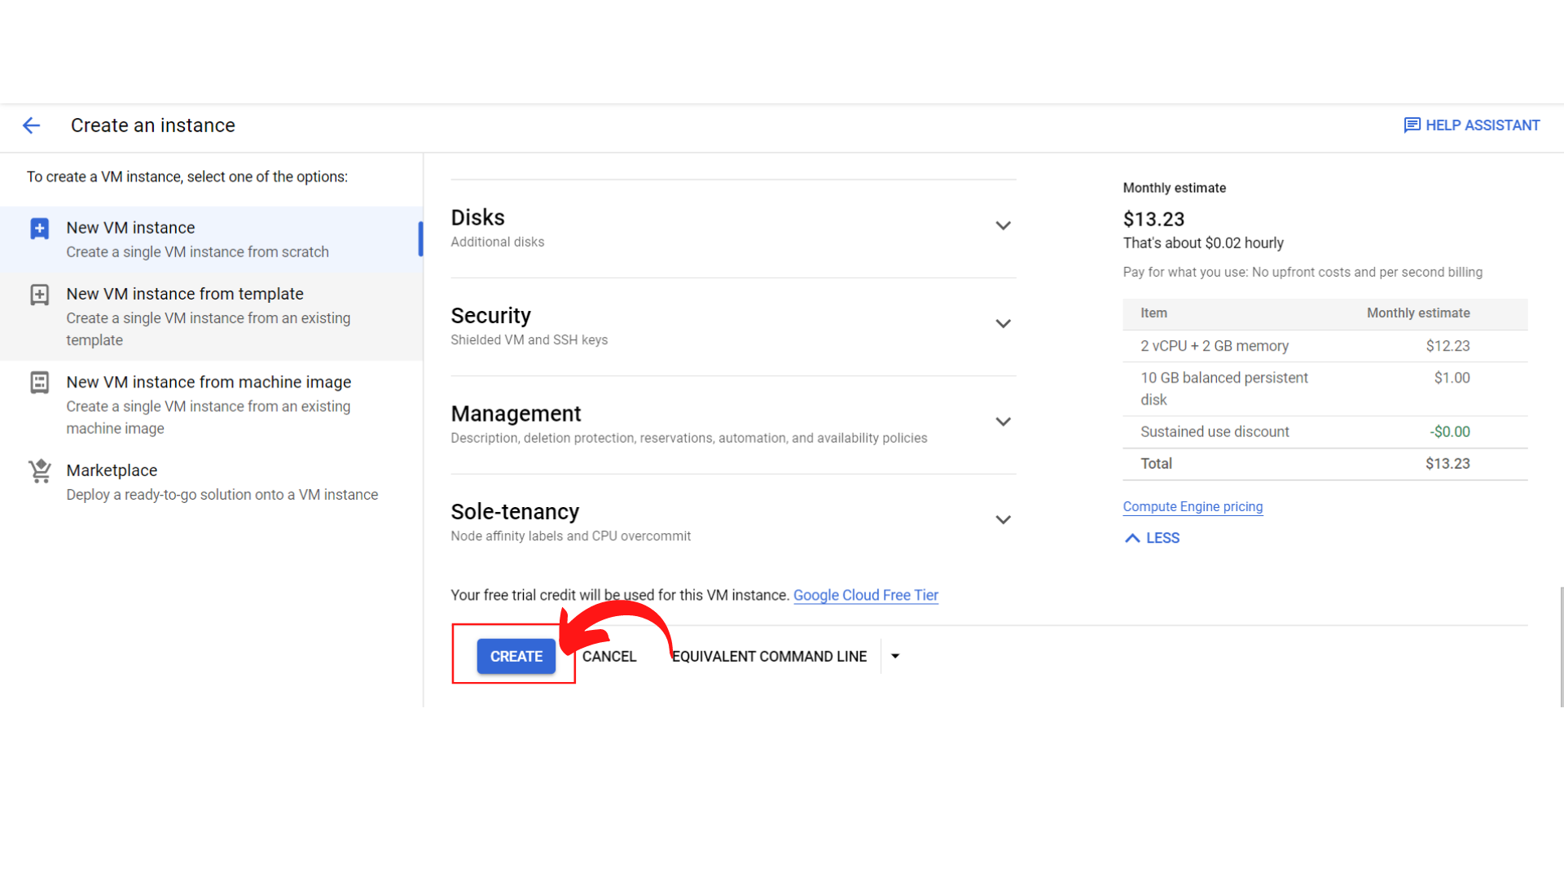

1. Now your screen should look like this with *status → “green color”.* That means your instance is running.

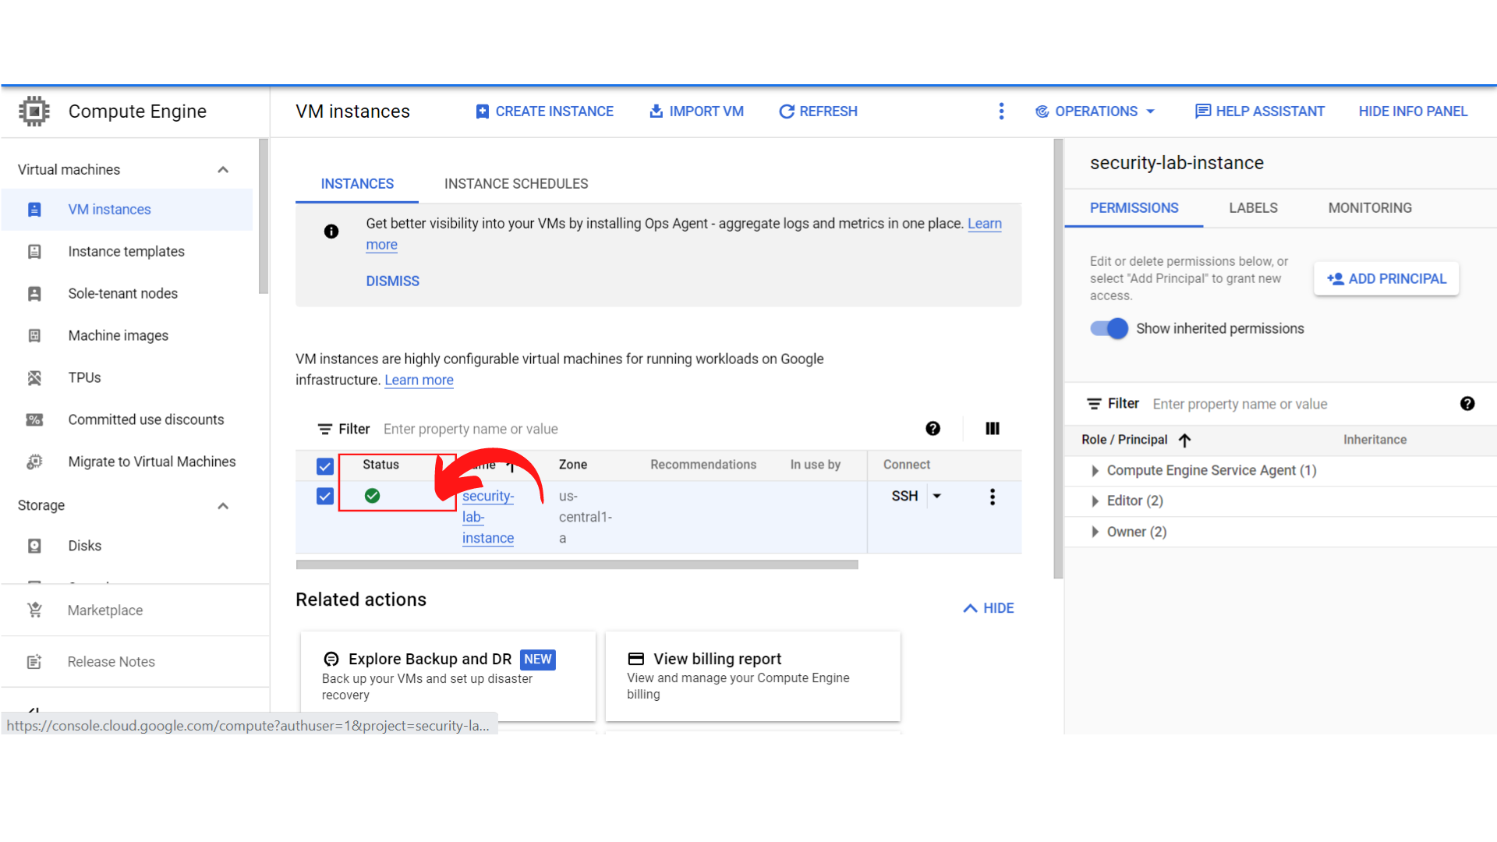

1. That’s it, you have successfully created your instance on GCP.